**SHALOM WAKONYO NDONGA**

**ABMI/00958/2021**

**BUSINESS PLAN**

1. **DECLARATION**

I hereby declare that this business plan is my original work and has not been presented in any university for any award.

Shalom Wakonyo Ndonga. ABMI/00958/2021.

Signature…………………

This business plan has been submitted with the approval of the supervisor.

Dr. Ruth Ruhiu.

Signature…………………

Date………………………

1. **ACKNOWLEDGEMENT**

I am sincerely grateful to everyone who supported me in completing this business plan. My heartfelt thanks go to my family for their unwavering encouragement, to my classmates for their collaboration, and to my supervisor for their invaluable guidance and insights. This achievement would not have been possible without their collective wisdom and motivation. I also acknowledge the effort and perseverance it took to bring this project to fruition, and I appreciate the learning opportunities it provided.

1. **DEDICATION**

To those who inspire me to grow,

to my family for their endless support,

and to every voice that guided me along the way—

this work is for you.

1. **TABLE OF CONTENTS**

**CONTENTS**

**i) Declaration………………………………………………………………….. 1**

**ii) Acknowledgement…………………………………………………………. 1**

**iii) Dedication……………………………………………………………………. 1**

**EXECUTIVE SUMMARY**

**Business Mission and Vision………………………………………………………. 6**

**Business Description………………………………………………………………. 6**

**Marketing Plan……………………………………………………………………. 6**

**Organizational and Management plan…………………………………………… 7**

**Production and Operational Plan…………………………………………………. 7**

**Financial Plan………………………………………………………………………. 7**

**Risk Analysis and Mitigation Strategies………………………………………….. 8**

**CHAPTER ONE: BUSINESS DESCRIPTION**

**1.1 Background………………………………………………………………... 9**

**1.2 Business Name and Logo………………………………………………… 9**

**1.3 Business Location and Address…………………………………………… 10**

**1.4 Form of ownership………………………………………………………… 11**

**1.5 Type of business…………………………………………………………… 12**

**1.6 Products and services……………………………………………………… 12**

**1.7 Justification of opportunity. ……………………………………………… 12**

**1.8 Industry Analysis………………………………………………………… 12**

**1.9 Business Goals……………………………………………………………... 13**

**1.10 Entry and growth strategy………………………………………………... 14**

**CHAPTER TWO: MARKETING PLAN**

**2.0 Introduction……………………………………………………………………. 14**

**2.1 Customer Profile………………………………………………………………. 14**

**2.2 Competitor Analysis…………………………………………………………… 15**

**2.3 Market Share and Analysis…………………………………………………… 15**

**2.4 Advertising and sales promotion……………………………………………… 16**

**2.5 Pricing Strategy………………………………………………………………. 16**

**2.6 Sales Tactics……………………………………………………………………. 17**

**2.7 Distribution Strategy…………………………………………………………… 17**

**CHAPTER THREE: ORGANIZATION AND MANAGEMENT PLAN**

**3.0 Introduction…………………………………………………………………… 17**

**3.1 Business Manager……………………………………………………………… 18**

**3.2 Key Personnel…………………………………………………………………. 19**

**3.3 Other Personnel………………………………………………………………. 19**

**3.4 Recruitment and Training……………………………………………………. 19**

**3.5 Remuneration and Incentives………………………………………………… 20**

**3.6 Legal Requirements……………………………………………………………. 20**

**3.7 Support Services………………………………………………………………… 20**

**CHAPTER 4: PRODUCTION AND OPERATIONAL PLAN**

**4.0 Introduction……………………………………………………………. 21**

**4.1 Production Facilities and Capacity…………………………………… 21**

**4.2 Production Strategy- Product design and development………………. 22**

**4.3 Production Process……………………………………………………... 22**

**4.4 Rules and Regulation Affecting Production…………………………. 23**

**CHAPTER FIVE: FINANCIAL PLAN**

**5.1 Pre-operational Costs…………………………………………………. 24**

**5.2 Working Capital Estimation…………………………………………… 24**

**5.3 Projected Cash Flow Statement………………………………………… 24**

**5.4 Pro Forma Income Statement…………………………………………… 25**

**5.5 Pro forma Balance sheet …………………………………………………. 26**

**5.6 Break Even Analysis……………………………………………………… 27**

**5.7 Profitability Ratios……………………………………………………... 27**

**5.8 Proposed Capitalization………………………………………………… 27**

**CHAPTER SIX: RISK ANALYSIS AND MITIGATION STRATEGIES**

**6.1 Locational Risk………………………………………………………… 28**

**6.2 Marketing Risks…………………………………………………………. 28**

**6.3 Management Risks……………………………………………………… 29**

**6.4 Production Risks………………………………………………………… 30**

**6.5 Financial Risks…………………………………………………………… 30**

**6.6 Political Risks……………………………………………………………. 30**

**6.7 Economic Risks……………………………………………………………. 31**

**6.8 Social-cultural Risks……………………………………………………… 31**

**6.9 Technological Risks………………………………………………………. 31**

**6.10 Ecological/Physical environment Risks………………………………… 32**

**6.11 Legal and regulatory Risks……………………………………………… 4**

**Figure 1 Business Logo……………………………………………………… 10**

**Figure 2 Location sketch map………………………………………………… 11**

**Figure 3 Market Share……………………………………………………… 16**

**Table 1 Key Personnel………………………………………………………… 18**

**Table 2 Other Personnel………………………………………………………... 19**

**Table 3 Remuneration per Month……………………………………………... 20**

**Table 4 Support Services……………………………………………………… 20**

**Table 5 Pre-operational Costs………………………………………………… 24**

**Table 6 Working Capital Estimation…………………………………………. 25**

**Table 7 Project Cash Flow Statement…………………………………………... 25**

**Table 8 Pro Forma Income Statement………………………………………… 27**

**Table 9 Pro forma Balance Sheet………………………………………………… 27**

**EXECUTIVE SUMMARY:**

**Business Mission and Vision**

My_Girlie_World is dedicated to empowering young urban women (18–35) by offering trendy, affordable fashion that boosts confidence and self-expression. Our vision is to become a leading digital-first brand in Kenya, recognized for quality, inclusivity, and seamless shopping experiences. We aim to foster a loyal community through engaging social media content and customer-centric service. By blending style with accessibility, we inspire women to embrace their individuality. Ultimately, we strive to make fashion fun, effortless, and budget-friendly.

**Business Description**

My_Girlie_World is an e-commerce fashion brand specializing in casual and semi-formal wear for young women with disposable incomes of KSh 2,000–5,000 monthly. Operating primarily through Instagram, TikTok, and WhatsApp, we leverage influencer marketing and interactive features like AR try-ons. Our initial product line includes curated dresses, tops, and accessories. With a target of 5,000 customers in Year 1, we prioritize convenience, fast delivery, and responsive customer service. The brand differentiates itself through hyper-relevant trends and a relatable digital presence.

**Marketing Plan**

Our strategy focuses on Instagram and TikTok, where 68% of users make impulse purchases based on influencer content. Key tactics include shoppable posts, user-generated content campaigns, and limited-time offers to drive urgency. We will collaborate with micro-influencers to build authenticity and trust. WhatsApp will serve as a direct ordering and customer care channel. Additionally, seasonal discounts and referral incentives will enhance retention. The goal is to achieve a 1% market share (5,000 customers) within the first year.

**Organizational and Management Plan**

The business will be led by a small, agile team comprising a founder (CEO), a social media manager, and a customer service representative. Outsourced roles include logistics and content creation. Decision-making is centralized for speed, with a flat hierarchy to encourage innovation. Training will emphasize brand voice consistency and data-driven adjustments. Future hires will scale with demand, focusing on digital marketing and operations. Our culture prioritizes creativity, adaptability, and customer obsession.

**Production and Operational Plan**

Inventory will be sourced from local suppliers and pre-ordered to minimize waste, with a just-in-time restocking model. Quality checks and ethical sourcing are paramount. Orders will be fulfilled via third-party logistics for efficiency, with a 3–5 day delivery window. Customer inquiries will be managed through WhatsApp and email, with a 12-hour response guarantee. Key metrics include order accuracy, delivery time, and return rates, monitored weekly for continuous improvement.

**Financial Plan**

Initial funding of KSh 1.5 million will cover inventory, marketing, and operations. Revenue projections estimate KSh 8 million in Year 1, with a 30% gross margin. Break-even is expected by Month 10. Primary costs include influencer collaborations (25%), ads (20%), and logistics (15%). Profit reinvestment will fuel inventory expansion and tech upgrades. Financial controls include monthly cash flow reviews and a 6-month emergency fund.

**Risk Analysis and Mitigation Strategies**

Key risks include supply chain delays (mitigated by multi-supplier partnerships), low customer retention (addressed via loyalty programs), and digital fraud (prevented with secure payment gateways). Competitor saturation will be countered through niche targeting and USP reinforcement. Economic downturns will be navigated with flexible pricing tiers. Regular SWOT analyses will ensure proactive adaptation to market shifts.

**CHAPTER ONE: BUSINESS DESCRIPTION**

**1.1 Background**

My_Girlie_World will be a boutique online fashion brand founded by Ms. Shalom Wakonyo Ndonga, dedicated to bringing Kawaii and hyperfeminine fashion to Kenya’s underserved market. The brand will emerge from the founder’s personal struggle to find locally sourced, expressive fashion pieces, bridging a gap by offering curated, custom-made apparel and accessories. Emphasizing individuality and self-expression, My_Girlie_World will combine whimsical aesthetics with technical precision, reflected in its name’s intentional underscore as a nod to the founder’s tech background. The brand will target Kenya’s youthful demographic, leveraging e-commerce growth and niche demand for hyperfeminine styles.

**1.2 Business Name and Logo**

The name My_Girlie_World, with its underscore symbolizing the founder’s technical expertise, will embody the brand’s fusion of creativity and innovation. Its slogan, “Your Ethereal Garden,” will encapsulate the dreamy, Asian-inspired aesthetic, reinforced by a logo featuring delicate floral motifs. This visual identity will distinguish the brand in digital and physical touchpoints. The logo’s design will prioritize versatility for use across packaging, social media,

and future merchandise.

FIGURE 1: BUSINESS LOGO

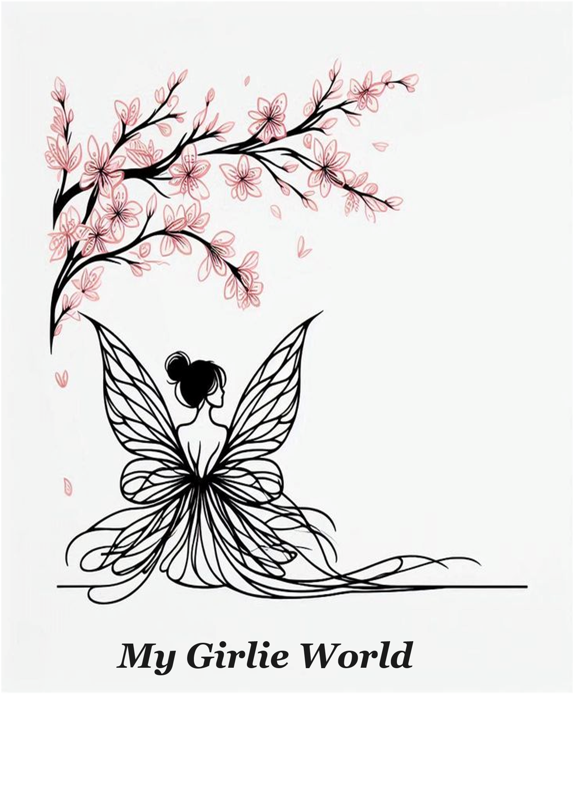

**1.3 Business Location and Address**

Initially digital-only, My_Girlie_World will operate from Moreteas Ladies Hostels, PR4G+V6 Nairobi, serving as the hub for packaging, inventory, and legal registration. This location will minimize overhead costs while enabling nationwide reach through e-commerce platforms. Contact channels will include a dedicated business email (to replace the founder’s personal account), a customer service phone line (+254 704 9477 06), and Instagram (@My_Girlie_World.ke) for engagement.

FIGURE 2: LOCATION SKETCH

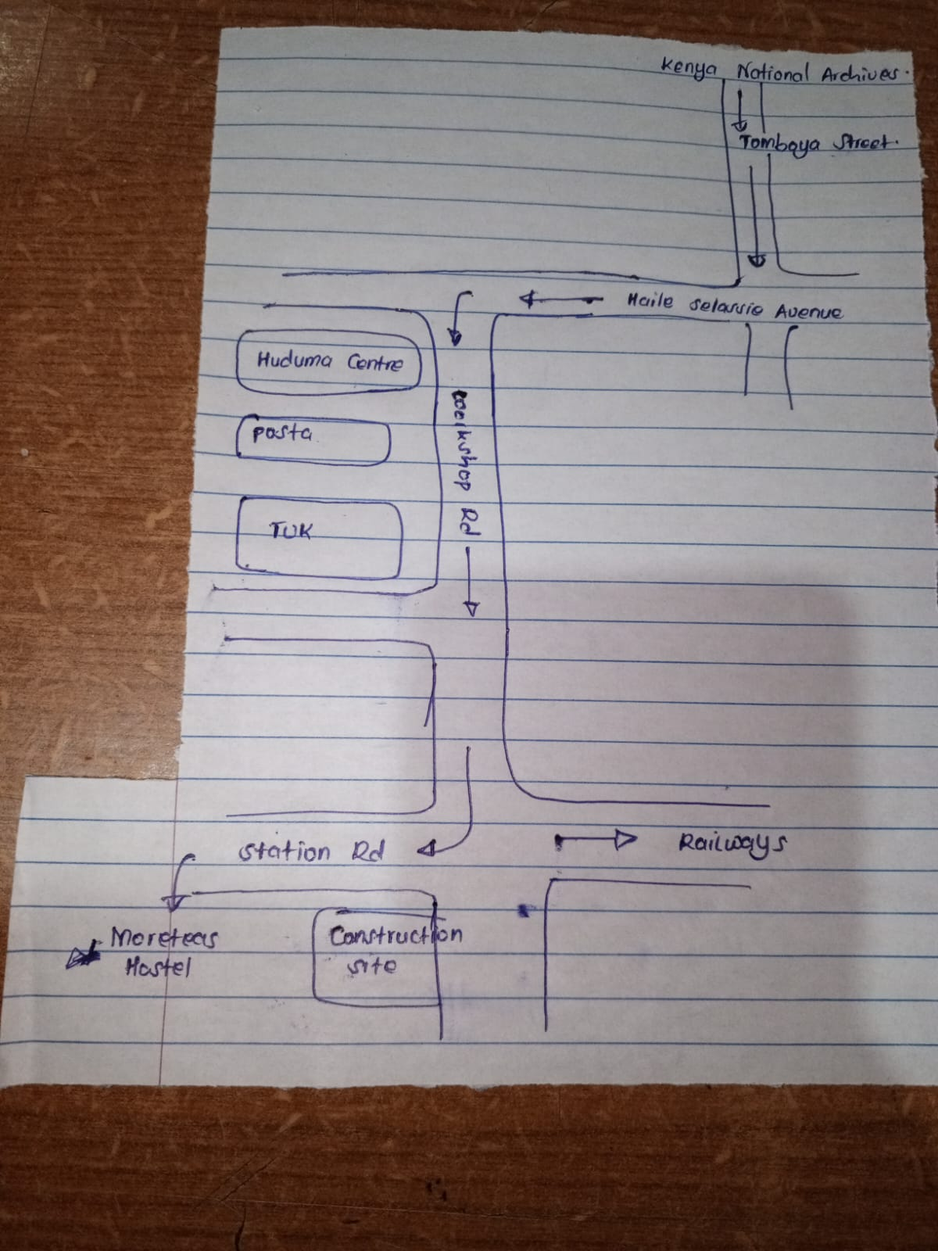

**1.4 Ownership**

My_Girlie_World will be structured as a sole proprietorship, allowing the founder to retain full creative control and operational agility. This ownership model will offer tax simplicity and low startup costs, making it ideal for an emerging fashion brand. To mitigate risks such as personal liability, the business will maintain separate financial accounts and explore insurance options. As the brand expands, the ownership structure may evolve to accommodate partnerships or investors. The sole proprietorship model will provide the flexibility needed to adapt to market demands and growth opportunities.

**1.5 Type of Business**

My_Girlie_World will operate as a vertically integrated startup, handling in-house design, local manufacturing, and direct-to-consumer sales. This model will ensure quality control, support local artisans, and offer customization options to customers. The business will focus on limited-edition and made-to-order fashion items, reducing waste and maintaining exclusivity. By leveraging Kenyan fabrics and craftsmanship, the brand will promote sustainability and local economic growth. This approach will differentiate My_Girlie_World from competitors relying on mass-produced imports.

**1.6 Products and Services**

The brand will specialize in Kawaii-inspired fashion, including dresses, platform heels, and delicate jewelry, all crafted from locally sourced materials. Custom-made apparel will be a core offering, allowing customers to personalize designs to their preferences. Additional services will include virtual styling consultations and quarterly subscription boxes featuring exclusive pieces. The vertically integrated model will enable My_Girlie_World to maintain high standards while fostering customer loyalty. These offerings will cater to a niche market seeking unique, expressive fashion choices.

**1.7 Justification of Opportunity**

Kenya’s youthful demographic, with 60% of the population under 25, presents a significant opportunity for My_Girlie_World. The scarcity of hyperfeminine fashion locally and the projected 18% annual growth in e-commerce fashion further validate the business concept. Collaborations with emerging designers and AI-driven personalization tools, such as a “Magic Assistant” chatbot, will enhance the brand’s competitive edge. The niche Kawaii fashion segment is expected to outpace general fashion growth by 25%, positioning My_Girlie_World for success. These factors collectively justify the brand’s market entry and potential for expansion.

**1.8 Industry Analysis**

My_Girlie_World will operate within Kenya’s e-commerce fashion market, valued at KSh 210 million annually. The country’s 28% e-commerce penetration and 87% mobile money adoption rate will facilitate seamless transactions. The brand will leverage these trends while addressing risks such as copycats through rapid design iterations and strong intellectual property measures. By focusing on a niche segment, My_Girlie_World will carve out a distinct space in the competitive fashion industry. Continuous market analysis will ensure the brand remains responsive to evolving consumer preferences.

**1.9 Business Goals**

Short-Term (0–12 Months):

1. Launch the e-commerce platform.
2. Acquire the first 100 customers.

2026:

1. Expand product categories by two.
2. Achieve 500 repeat customers.

3.Hire the first full-time employee.

2027:

1. Open the first pop-up shop.
2. Reach break-even.
3. Partner with two designers.

**1.10 Entry and Growth Strategy**

My_Girlie_World will debut with three hero products and a Founder’s Collection to attract early adopters. Introductory pricing strategies, such as 15% discounts and tiered bundles, will drive initial sales. Social media campaigns (#MyGirlieWorldKe) and collaborations with nano-influencers will amplify brand awareness. Success metrics will include a 70% repeat purchase rate for hero products and a threefold increase in social media followers within six months. These strategies will lay the foundation for sustainable growth and market penetration.

**CHAPTER TWO: MARKETING PLAN**

**2.0 Introduction**

My_Girlie_World will target urban Kenyan women aged 18–35, focusing on cities like Nairobi and Mombasa, which generate 62% of the country’s GDP. These consumers are tech-savvy, spending an average of 2.1 hours daily on fashion-related content, and prefer mobile-first shopping experiences. The brand will align its marketing efforts with these behaviors to maximize engagement and conversions. By leveraging digital platforms and localized strategies, My_Girlie_World will establish a strong presence in Kenya’s competitive fashion market.

**2.1 Customer Profile**

The primary customer segments will include students, professionals, and content creators. Students will seek affordable, statement-making pieces influenced by campus trends. Professionals will value work-appropriate Kawaii styles and customization options. Content creators, known for driving user-generated content (UGC), will receive free product seeding to organically promote the brand. Understanding these segments will enable My_Girlie_World to tailor its offerings and marketing messages effectively.

**2.2 Competitor Analysis**

Local competitors like KawaiiKeen lack customization options, while international players such as Shein face challenges like high shipping costs and long delivery times. My_Girlie_World’s made-to-order model and “Made in Kenya” ethos will address these gaps, offering faster delivery and personalized designs. The current supply shortage of Kawaii dresses (approximately 3,000 units monthly) presents a clear opportunity for the brand to capture market share. Competitive pricing and superior customer service will further differentiate My_Girlie_World.

**2.3 Market Share and Analysis**

The brand will target urban women aged 18–35 with disposable incomes of KSh 2,000–5,000 per month. With 500,000 potential customers in this demographic, My_Girlie_World aims to capture 1% market share (5,000 customers) in its first year. The brand will leverage Instagram and TikTok, where 68% of consumers make impulse purchases based on influencer content. Strategies like shoppable posts, AR try-ons, and WhatsApp ordering will enhance accessibility and engagement.

**2.4 Advertising and Sales Promotion**

Digital campaigns will receive 50% of the marketing budget, focusing on TikTok and Instagram ads targeting keywords like “Kawaii fashion Kenya.” Experiential tactics, such as pop-up events at Nairobi cafes, will build offline buzz. Packaging will include handwritten notes and free stickers to encourage social sharing and repeat purchases. These efforts will create a cohesive brand experience across online and offline touchpoints.

**2.5 Pricing Strategy**

My_Girlie_World will adopt a premium pricing strategy, with entry-level accessories starting at KSh 800, signature dresses priced between KSh 3,500–6,000, and bespoke designs at KSh 8,000 and above. Limited-edition items will use dynamic pricing, increasing by 5% weekly to create urgency. Transparent communication about artisan wages and local sourcing will justify premium pricing and build customer trust.

**2.6 Sales Strategy**

My_Girlie_World will use a multi-channel approach targeting young Kenyan women through: E-commerce (curated collections, flash sales, limited-edition drops), social commerce (Instagram/TikTok shoppable posts, influencer collaborations), offline activations (campus pop-ups, ambassador programs), loyalty incentives (discounts, redeemable points for referrals/reviews), data-driven optimization (cart recovery, analytics for inventory/promotions). The strategy focuses on urgency, convenience, and retention to boost conversions and lifetime value.

**2.7 Distribution Strategy**

The brand will begin as an online business, shipping orders from its Nairobi studio via reliable couriers. Pickup points at partner locations will serve customers outside major cities. Packaging will feature branded pink mailers and thank-you notes to enhance unboxing experiences. Seasonal pop-ups in high-traffic areas will be introduced as demand grows, with international shipping to East Africa planned for Year 2. Lean inventory practices, including made-to-order items and monthly restocks, will minimize waste and optimize cash flow.

**CHAPTER THREE: ORGANIZATION AND MANAGEMENT PLAN**

**3.0 Introduction**

My_Girlie_World will implement a lean organizational structure designed for agility and scalability in its initial growth phase. The management approach will blend creative direction with operational efficiency to maintain the brand’s niche positioning. Key personnel will be selected for complementary skill sets that align with the brand’s ethos of merging technology and fashion. As the business scales, the structure will evolve to incorporate specialized roles while preserving the founder’s vision. This chapter outlines the human capital strategy that will drive operational execution.

**3.1 Management Structure**

The founder will serve as Creative Director and CEO, overseeing all strategic decisions and brand identity. A flat hierarchy will be maintained initially, with the founder directly supervising three core functions: design/production, digital marketing, and customer experience. This streamlined structure will enable rapid decision-making during the launch phase. Advisory support will be sought from mentors in e-commerce and fashion manufacturing to strengthen governance. The structure will transition to a departmental model upon achieving the 500-customer milestone outlined in the business goals.

**3.2 Key Personnel**

The founding team will consist of:

|  |  |  |
| --- | --- | --- |
| **Key Personnel:** | **Duties:** | **Skill/Qualification:** |
| 1. Creative Director | Branding, final decision-making and partnership curation. | Certification in Business related fields.  Good Leadership skills |
| 1. Managing Director | Manages the design teams working for My_Girlie_World | Certification in Fashion related fields.  Good creative/Innovative vision  Project management skills. |
| 1. Digital Marketing Lead | Handling the digital marketing teams. | Certification in social media management and marketing |
| 1. Operations Coordinator | Managing inventory and logistics of the business. | Degreen in Supply Chain Management, Procurement, Accounting. |

These roles will be filled through a hybrid model – the founder assuming the creative role initially, the managing director being the first initial designer and freelance specialists contracted for marketing and operations. The first full-time employee (Operations Coordinator) will be hired when monthly orders exceed 50 units. Qualifications will emphasize prior experience in African e-commerce, with language skills in Swahili and English required for customer-facing roles.

**3.3 Other Personnel**

|  |  |  |
| --- | --- | --- |
| **Personnel:** | **Duties:** | **Skills/Qualifications:** |
| 1. Social media Assistants | Schedules content, monitors engagement, and runs influencer coordination | Certificate in Digital Marketing, Knowledge of Trends |
| 1. Design teams ie; other tailors in the business | Create patterns for the garments, creating the clothes and accessories for the business. | Certification in Fashion design |
| 1. Photographer and Graphic Designer | Taking the product icon shoots for the website. Develops marketing visuals, banners, and branding material | Degree/Diploma in Graphic Design, Proficiency in Design software and taking professional photo shots. |
| 1. Customer Services | Respond to customer queries on orders and issues experienced while shopping. | Diploma in Communication, Fluency in English and Kiswahili |

**3.4 Recruitment and Training**

A phased hiring approach will prioritize Kenyan talent with specialized skills in digital fashion retail. Recruitment will leverage platforms like LinkedIn and BrighterMonday, with 30% of roles reserved for graduates of local fashion institutes. All hires will undergo a two-week immersion program covering the brand’s Kawaii aesthetic philosophy, ethical production standards, and proprietary order management systems. Performance incentives will include revenue-sharing for team members who propose best-selling designs. The training budget will allocate 5% of Year 1 payroll to upskill staff in sustainable fashion practices.

**3.5 Remuneration and Incentives**

Salaries will follow Kenyan fashion industry benchmarks:

|  |  |
| --- | --- |
| **Role:** | **Salaries (ksh):** |
| 1. Creative Director | KSh 120,000/month (Year 2) |
| 1. Digital Marketing Lead | KSh 20,000/month (freelance initially) |
| 1. Operations Coordinator | KSh 60,000/month (full-time at 50+ orders) |

Performance bonuses (5–10% of revenue) will reward hitting KPIs like customer retention (70% target). Staff will receive free quarterly apparel allowances (KSh 15,000 value annually).

**3.7 Legal and Compliance**

My_Girlie_World will register as a business name under the Kenyan Companies Act, with trademark applications filed for the brand name, logo, and signature designs. Necessary permits include: Single Business Permit from Nairobi County, NSSF and NHIF compliance for employees, KRA PIN for tax remittance.

Intellectual property protection will be prioritized through design patents for unique garment patterns. The business will retain a legal consultant on retainer to handle supplier contracts and copyright enforcement. Monthly compliance audits will ensure adherence to data protection laws governing customer information collected through the e-commerce platform.

**3.7 Support Services**

|  |  |  |
| --- | --- | --- |
| **Support Services:** | **Services needed:** | **Provider:** |
| 1. Banking | Business account, mobile money | Equity Bank (Fees: KSh 5,000/yr) |
| 1. Delivery | Nationwide couriers | Sendy (KSh 250–800/package) |
| 1. Insurance | Asset & liability coverage | Britam (KSh 20,000/yr) |
| 1. Warehousing | Shared storage space | StorLogic Nairobi (KSh 15,000/mo) |

**CHAPTER FOUR: PRODUCTION OPERATION PLAN**

**4.0 Introduction**

My_Girlie_World will structure its production operations to meet the demands of a dynamic and youthful female market in Kenya. The production plan will focus on sourcing, curating, and delivering fashion-forward products, accessories, beauty items, and digital content that align with contemporary trends and customer expectations. This chapter will outline how MY_GIRLIE_WORLD will manage its production inputs, strategic design processes, and scalable infrastructure. Emphasis will be placed on quality control, customer satisfaction, and operational efficiency. MY_GIRLIE_WORLD will also integrate ethical production practices and compliance with health and environmental regulations.

* 1. **Production Facilities and Capacity**

The Nairobi studio (20 sqm) will house: Design workstation with CAD software, photography corner for product shoots, storage racks for fabrics and finished goods. Key equipment investments include: Industrial sewing machine (KSh 45,000), embroidery machine (KSh 120,000) – Year 2 purchase, barcode scanner for inventory (KSh 8,500). A memorandum of understanding will be signed with nearby hostels for shared use of laundry facilities. The operational layout will follow 5S methodology to optimize the compact workspace.

**4.2 Production Strategy – Product Design and Development**

My_Girlie_World will adopt a demand-driven design strategy informed by customer insights, digital analytics, and social listening tools across platforms such as TikTok and Instagram. Product development will involve collaborative collections with local designers and artisans, offering curated exclusives in fashion, self-care, and lifestyle categories. My_Girlie_World will roll out seasonal product themes aligned with school calendars, national holidays, and cultural events to stay culturally relevant. All product designs will be tested in focus groups and launched as limited collections to build scarcity and urgency. The strategy will focus on balancing affordability with aspirational value, making fashion and beauty more accessible without diluting brand quality.

**4.3 Production Process**

The made-to-order model will follow six standardized steps:

1. Customer places order via website with customization options
2. Automated pattern generation using TUKAcad software
3. Fabric procurement from pre-approved suppliers (Rivatex, Sunflag)
4. Production batch assignment to the in-house My_Girlie_World design teams.
5. Quality inspection at central studio
6. Eco-friendly packaging and dispatch

For subscription boxes, production will occur quarterly with a 30-day lead time. The business will maintain a lean inventory of only 10 ready-to-ship units per bestseller design to accommodate urgent orders.

**4.4 Rules and Regulation affecting Production**

My_Girlie_World will adhere to the Kenya Bureau of Standards (KEBS) certification requirements for cosmetics and personal care items, ensuring all listed products are registered and safe for use. All business premises will comply with county-level licensing, fire safety regulations, and zoning rules applicable to e-commerce logistics facilities. MY_GIRLIE_WORLD will ensure all software tools and design assets are properly licensed to avoid intellectual property infringement. The platform will maintain tax compliance in alignment with Kenya Revenue Authority regulations, including VAT obligations and digital services tax where applicable. Production partnerships with local artisans will also be governed by legal agreements covering work standards, pricing, and delivery timelines.

**4.4.1 Health, Environmental and Safety Regulations**

My_Girlie_World will institute health-conscious handling procedures especially for fabric to be used to ensure no risk of irritants, regulated temperature zones and storage for more delicate fabrics. Environmental sustainability will be addressed through the use of biodegradable packaging, promotion of reusable items, and supplier partnerships with eco-friendly brands. The warehousing facility will be equipped with first-aid kits, smoke detectors, and emergency exits in line with the Occupational Safety and Health Act. Staff working in production roles will receive routine health checks, safety training, and emergency response orientation. MY_GIRLIE_WORLD will also comply with National Environment Management Authority (NEMA) guidelines on waste disposal, emissions, and energy efficiency.

**CHAPTER FIVE: FINANCIAL PLAN**

**5.1 Pre-operation Costs**

|  |  |
| --- | --- |
| **Item** | **Amount in KSH** |
| Industrial sewing machine | 45, 000 |
| Barcode scanner for inventory | 8,500 |
| My_Girlie_World setup -Rent, business supplies. | 150, 000 |
| **TOTAL COSTS** | **203, 500** |

**5.2 Working Capital Estimation**

|  |  |  |  |
| --- | --- | --- | --- |
| **Items (Expenses)** | **1ST Month** | **2nd Month** | **3rd Month** |
| Fabric/ Material | 40, 000 | 45, 000 | 50,000 |
| Set-up | 203, 500 | 100,000 | 100, 000 |
| Marketing | 25, 000 | 20, 000 | 25, 000 |
| Salaries | 50, 000 | 50, 000 | 50, 000 |
| **TOTAL W.C** | **318, 500** | **210, 000** | **225, 000** |

**5.3 Projected Cashflow Statement**

|  |  |  |  |  |  |
| --- | --- | --- | --- | --- | --- |
| **Month** | **Opening Balance** | **Cash Inflows (Sales + Other)** | **Cash Outflows (Costs)** | **Net Cashflows** | **Closing Balance** |
| January | 500, 000 | 200, 000 (Pre-orders + Launch) | 243, 500 (Inventory + Set-up) | (43, 500) | 457, 000 |
| February | 457,000 | 300, 000 (Early sales) | 75,000 (Marketing + Salaries) | 225, 000 | 682, 000 |
| March | 682, 000 | 400, 000 | 350, 000 | 50, 000 | 732, 000 |
| April | 732, 000 | 500,000 | 300,000 | 200, 000 | 932, 000 |
| May | 932, 000 | 600, 000 (Seasonal Boost) | 350,000 | 250, 000 | 1, 182, 000 |
| June | 1, 182, 000 | 650,000 | 400, 000 | 250, 000 | 1,432, 000 |
| July | 1, 432, 000 | 700,000 (Mid-Year Sales) | 450, 000 | 250, 000 | 1, 682, 000 |
| August | 1, 682, 000 | 750, 000 (Holiday Season) | 500, 000 | 250, 000 | 1, 932, 000 |
| September | 1, 932, 000 | 800, 000 | 500, 000 | 300, 000 | 2, 232, 000 |
| October | 2, 232, 000 | 900, 000 (Holiday Prep) | 550, 000 | 350, 000 | 2, 582, 000 |
| November | 2, 582, 000 | 1, 200, 000 (Black Friday) | 600, 000 | 600, 000 | 3, 182, 000 |
| December | 3, 182, 000 | 1, 500, 000 (Holiday Sales) | 700, 000 | 800, 000 | 3, 982, 000 |

**5.4 Pro Forma Income Statement**

|  |  |  |  |
| --- | --- | --- | --- |
| **ITEMS** | **YEAR ONE (KSH)** | **YEAR TWO** | **YEAR THREE** |
| Sales | 9, 000, 000 |  |  |
| Less Purchases | 5, 018, 500 |  |  |
| **Gross Profits** | **3, 981, 500** |  |  |
| **ALL EXPENSES** |  |  |  |
| **ITEMS** | **AMOUNT** |  |  |
| Salaries | 2, 400, 000 |  |  |
| Power | 120, 000 |  |  |
| Water | 120, 000 |  |  |
| Rent | 480, 000 |  |  |
| License | 5, 000 |  |  |
| Transport | 150, 000 |  |  |
| Advertisement | 340, 000 |  |  |
| Insurance | 50, 000 |  |  |
| Loan Interest | - |  |  |
| **TOTAL EXPENSES** | 3, 665, 000 |  |  |
| **Gross Profit Less Expenses** | 316, 500 |  |  |
| **Less Tax (30%)** | 94, 950 |  |  |
| **Net Profit After Tax** | 221, 550 |  |  |

**5.5 PRO FORMA BALANCE SHEET**

|  |  |  |  |
| --- | --- | --- | --- |
| **ITEMS** | **YEAR ONE (KSH)** | **YEAR TWO** | **YEAR THREE** |
| **ASSETS** | **AMOUNT (KSH)** |  |  |
| Current Assets |  |  |  |
| Cash | **3, 982, 000** |  |  |
| Inventory | **585, 000** |  |  |
| Prepaid Expenses | **100, 000\*** |  |  |
| **TOTAL CURRENT ASSETS** | **4, 667, 000** |  |  |
|  |  |  |  |
| **LIABILITIES & EQUITY** | **AMOUNT (KSH)** |  |  |
| Current Liabilities | 0 (Assumed) |  |  |
| Accounts Payable | 0 (Assumed) |  |  |
| Short- Term Loans | 0(Assumed) |  |  |
| **OWNER’S EQUITY** |  |  |  |
| Initial Investment | 500, 000 |  |  |
| Retained Earnings | 316, 500 |  |  |
| Total Equity | 816, 500 |  |  |
| **TOTAL CURRENT LIABILITIES** | 1, 633,000 |  |  |
|  |  |  |  |
| **FIXED ASSETS** | **AMOUNT (KSH)** |  |  |
| Equipment | 174, 000 |  |  |
| Leasehold Improvements | 150, 000 |  |  |
| **TOTAL FIXED ASSETS** | 324, 000 |  |  |

**5.6 Break Even Analysis**

**Break-Even Point (Units):**

Selling price per units = KSH. 3, 000

Variable Cost = (Purchases) KSH. 800

Fixed Costs = (Rent – 540, 000, Utilities – 240, 000, Salaries – 2, 400, 000) KSH. 3, 180, 000/12

* KSH. 265, 000

Revenue = KSH. 7, 800, 000

Contribution Margin = 3, 000 – 800 = KSH. 2, 200

Break – Even Units = 265, 000/2, 200 => 120.45

120 Units OR (120 * 3, 000 =>) KSH. 360, 000

**5.7 Profitability Ratios**

1. **. Gross Profit Margin; Gross Profit/Sales**

KSH. (3, 981, 500/9, 000, 000) * 100 => **44.24%**

1. **. Net Profit Margin; Net Profit/Sales**

**KSH.** (316, 550/9, 000, 000) * 100 **=> 3.52%**

1. **. Return on Assets; Net Profit/Sales**

**KSH.** (316, 550/9, 000, 000) * 100**=>6.61%**

1. **. Return on Equity; Net Profits/Sales**

**KSH.** (316, 550/816, 500) * 100 =>38**.76%**

**5.8 Proposed Capitalizations**

Based on the financial statements provided above, the business is entirely equity-financed:

**Current Capitalization:** 100% Equity (KSH 816,500) with 0% Debt.

**Recommended Capitalization:**

Consider adding moderate debt to improve ROE (debt-to-equity ratio of 0.5:1)

**Proposed Structure:**

Equity: KSH 816,500 (66.67%), Long-term Debt: KSH 400,000 (33.33%), Total Capital: KSH 1,216,500.

**Key Observations:**

The business shows positive cash flow throughout the year, ending with KSH 3,982,000.

Profitability ratios indicate healthy gross margins but relatively low net margins (3.52%), suggesting high operating expenses.

The break-even analysis shows the business exceeded its break-even point in Year 1.

The current all-equity structure is conservative; introducing some debt could improve returns.

Significant cash balances at year-end could be reinvested or used to fund expansion.

**CHAPTER SIX: RISK ANALYSIS AND MITIGATION STRATEGIES**

**6.1 Location Risks**

My_Girlie_World will operate from a central location in Nairobi, which may expose the business to disruptions arising from urban congestion, infrastructure strain, or county-specific regulations. Road closures, political demonstrations, or power outages may delay fulfilment timelines. To mitigate this, MY_GIRLIE_WORLD will secure backup storage outside the Central Business District and maintain relationships with multiple courier companies to ensure flexibility in routing. Generator backup, internet redundancy, and secondary delivery drop-off points will be incorporated into the location plan. The company will also routinely assess county compliance requirements and adapt operations as needed.

**6.2 Marketing Risks**

Marketing efforts may not achieve the desired traction due to saturation in the youth-focused fashion and beauty segments or ineffective campaign messaging. My_Girlie_World may face reduced reach or brand misalignment if its content does not resonate with the target demographic. To address this, My_Girlie_World will invest in data-driven marketing, influencer feedback loops, and dynamic A/B testing of messaging across platforms. Trends in youth preferences will be monitored weekly to inform quick campaign adjustments. Collaborations with micro-influencers and campus ambassadors will be used to localize brand voice and increase authenticity.

**6.3 Management Risks**

The risk of poor decision-making, inadequate leadership, or staff turnover may weaken My_Girlie_World's ability to achieve consistent execution. The loss of a key manager or gaps in communication between departments may delay strategic objectives. My_Girlie_World will develop structured Standard Operating Procedures for all departments and invest in leadership succession planning to build redundancy. All managers will be required to participate in quarterly performance evaluations and strategic alignment reviews. Professional development will be institutionalized to strengthen internal capacity and maintain a committed leadership culture.

**6.4 Production Risk**

Delays in inventory restocking, failure in quality assurance, or supplier inconsistencies may affect product availability and customer satisfaction. My_Girlie_World will mitigate this by working with multiple suppliers for each product category and incorporating minimum stock-level alerts in the inventory system. Local sourcing partnerships will be developed to reduce lead times and reliance on international shipping timelines. A quality assurance checklist will be applied at both supplier and warehouse levels. My_Girlie_World will also introduce a product return policy to maintain buyer trust in case of defects.

**6.5 Financial Risks**

Cash flow imbalances, high operational expenses, or unanticipated capital needs could restrict the growth of My_Girlie_World. Economic downturns or rising interest rates may also affect consumer spending power and financing costs. To safeguard against this, MY_GIRLIE_WORLD will maintain a rolling cash flow forecast and establish a reserve fund equivalent to three months of fixed operating expenses. Short-term working capital facilities will be pre-negotiated with partner banks to ensure liquidity. Financial planning will be reviewed monthly to stay ahead of expenditure and revenue fluctuations.

**6.6 Political Risks**

Policy changes, tax adjustments, or political instability in Kenya may have direct or indirect impacts on My_Girlie_World’s operations. Internet shutdowns or import restrictions could also disrupt access to platforms and inventory. MY_GIRLIE_WORLD will remain actively engaged with policy updates through business membership organizations and legal advisors. The platform will integrate secure offline functionalities to preserve transactions in case of temporary internet disruptions. The business will also diversify procurement sources to insulate against politically influenced supply chain limitations.

**6.7 Economic Risks**

Inflation, currency fluctuations, or reduced consumer spending can affect profitability and pricing power for My_Girlie_World. Volatility in fuel prices may increase delivery costs, while lower disposable income may reduce sales volume. MY_GIRLIE_WORLD will adopt a dynamic pricing engine that responds to cost fluctuations while preserving affordability for its core demographic. Supplier contracts will include pricing buffers to reduce the frequency of price adjustments. The business will also roll out budget-friendly bundles and promotions during economic downturns to maintain demand.

**6.8 Socio – Cultural Risks**

Shifts in fashion trends, cultural perceptions, or brand image misalignment may affect how My_Girlie_World is perceived by its intended market. Content or product offerings that conflict with local values may face backlash or poor market reception. MY_GIRLIE_WORLD will establish a cultural advisory panel made up of youth representatives, stylists, and community influencers to vet major campaigns. Social listening tools will be used to detect public sentiment and manage reputation in real time. Brand storytelling will prioritize empowerment, inclusivity, and relevance to Kenyan youth.

**6.9 Technological Risks**

Platform bugs, cybersecurity breaches, or technology obsolescence may disrupt My_Girlie_World’s ability to operate effectively. System downtime or data loss may reduce customer trust and sales velocity. MY_GIRLIE_WORLD will host its platform on a scalable cloud infrastructure with regular penetration testing, encrypted payment gateways, and daily backups. Technical support will be available on standby, and disaster recovery plans will be integrated into IT operations. The platform will also undergo quarterly upgrades to stay competitive in user experience and performance.

**6.10 Environmental Risks**

Climate change-related events such as floods or heatwaves could delay deliveries, damage goods, or increase operating costs. My_Girlie_World will prepare for such risks by reinforcing its packaging materials, working with logistics providers with route adaptation capabilities, and maintaining indoor climate-controlled warehousing. Seasonal trends will be factored into procurement planning to avoid inventory spoilage. MY_GIRLIE_WORLD will adopt an environmental policy that includes recycling programs and education campaigns promoting eco-conscious shopping. The business will also participate in sustainability alliances to advocate for green logistics innovation.

**6.11 Legal and Regulatory Risks**

Changes in tax law, e-commerce regulation, consumer rights policies, or employment laws could affect how My_Girlie_World operates. Non-compliance could result in fines, legal disputes, or reputational damage. MY_GIRLIE_WORLD will retain legal counsel and routinely audit all areas of compliance including licensing, digital transactions, and labor obligations. Regulatory updates will be reviewed quarterly and integrated into risk review meetings with department heads. The business will also maintain internal checklists to ensure ongoing adherence to all applicable legal requirements.